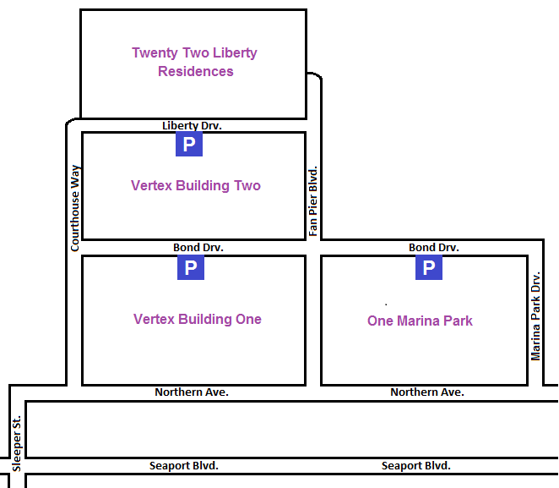
Garage Office
50 Northern Ave
11 Fan Pier Blvd
*The parking garage is inter-connected beneath the four buildings above.
Directions from I-93 South:
- Take exit 23 toward Purchase St.
- Turn left onto Seaport Blvd.
- Turn left onto Sleeper St.
- Turn right onto Northern Ave.
Directions from I-93 North:
- Take exit 20 toward Logan Airport
- Follow signs for South Boston
- Slight left onto E Service
- Continue onto Northern Ave.

Directions for I-90 West:
- Take exit 25 toward E Service Rd.
- Keep left at the fork and merge onto E Service Rd.
- Continue onto Northern Ave.
If the garage is full please enter at the One Marina Park entrance on Bond Drive. Inform the parking attendant at the base of the ramp that you are here for Vertex and they will provide parking.
Upon arrival to the garage you will be issued a parking ticket. Please keep this ticket secure, as you will need it when exiting the garage.

